Student Result Analysis
1. Project Overview
- This project aims to analyze a large student performance dataset to understand how demographic, social, and family-related factors influence academic achievement across Mathematics, Reading, and Writing.
- The focus is on identifying patterns, evaluating correlations, and understanding how factors like gender, parental education, marital status, and ethnic background impact student outcomes.
- The project also involves performing data cleaning, handling missing values, removing unnecessary fields, and creating visualizations to derive meaningful insights.

2. Dataset Summary
The dataset contains 30,641 student records with 14 variables, including demographic details, family background, and academic scores.
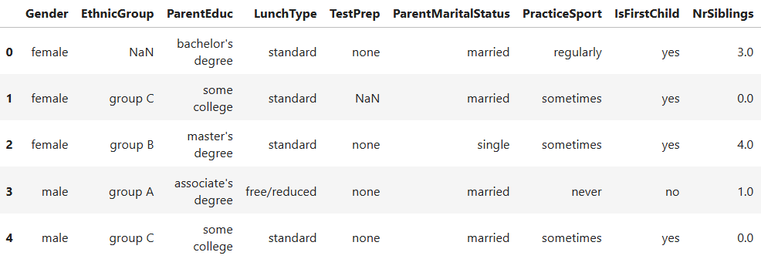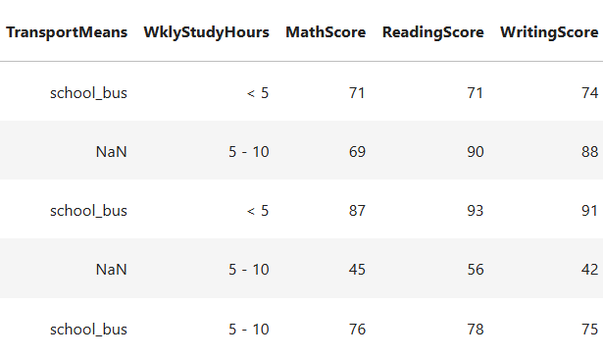

2.1 Key Attributes
- Target variables: MathScore, ReadingScore, WritingScore
- Categorical variables: Gender, EthnicGroup, ParentEduc, LunchType, etc.
- Numeric variables: NrSiblings, scores
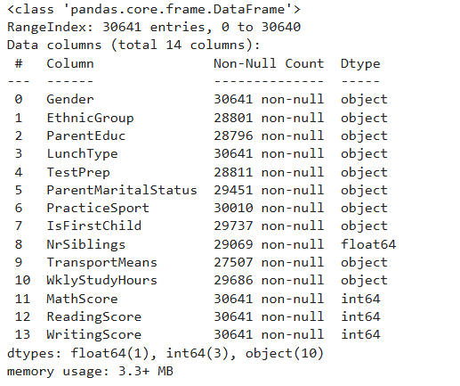
- Missing values:
  - Highest missing: TransportMeans (3134), EthnicGroup (1840), ParentEduc (1845)
  - No missing values in scoring columns, so no imputation required for analysis.
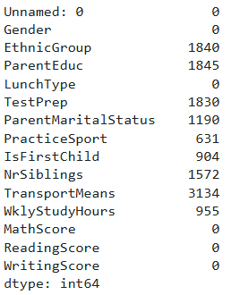

2.2 Statistical Highlights
- Average scores:
  - Math: 66.56
  - Reading: 69.37
  - Writing: 68.41
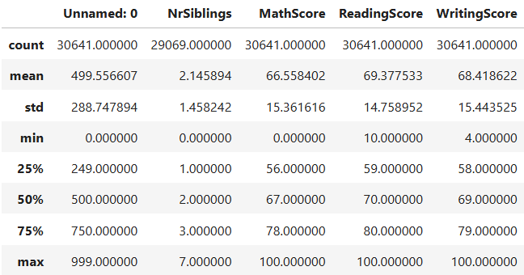
- Score ranges are valid: 0–100, indicating no data entry anomalies.

3. Data Transformation
- Removed the Unnamed: 0 column, which served no analytical purpose and only added redundancy to the dataset.
- Verified that the dataset contains zero duplicate rows, indicating high integrity and consistency of the provided data.
- Reviewed missing values and confirmed that while certain demographic fields contain gaps, the score-related fields are completely intact, enabling accurate evaluation of academic patterns.
- Prepared the dataset for visualization and further exploration by ensuring all key fields were clean, structured, and ready for analysis.

4. Data Visualization
4.1 Gender Distribution
- The visual analysis showed that the dataset contains female students are slightly more than male students but the difference in minimal.
- This distribution ensures that gender-based insights are naturally unbiased and reflective of the full dataset.
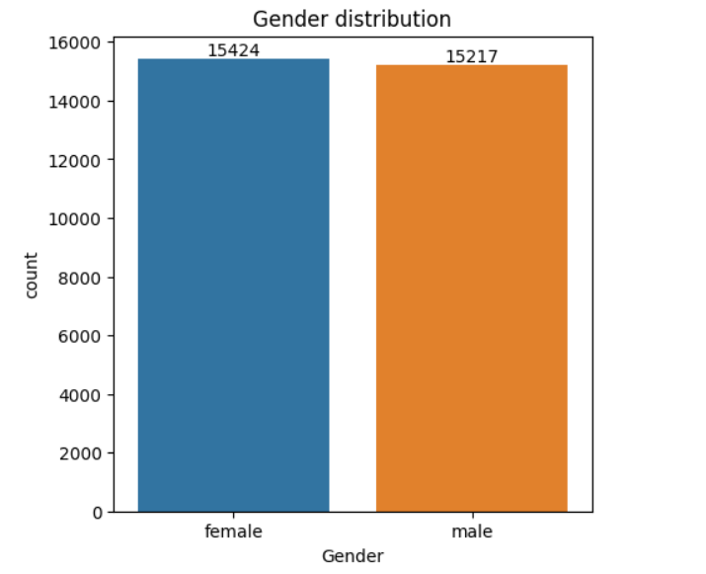

4.2 Impact of Parental Education on Student Scores
- Students with parents who hold Master’s degrees consistently achieve the highest average scores across all three subjects.
- Those whose parents have only completed some high school education scored the lowest on average, demonstrating a strong correlation between parental education and student academic success.
- The trend clearly indicates that the educational background of parents significantly contributes to shaping the academic readiness and support available to their children.
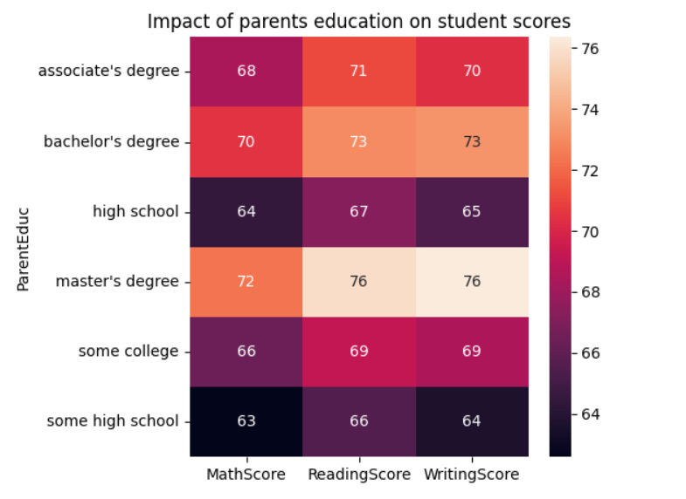
4.3 Impact of Parent Marital Status
- An analysis of marital status shows minimal score differences between students of married, divorced, single, or widowed parents.
- This suggests that marital structure alone does not significantly affect academic performance, and other environmental or educational factors play a much larger role.
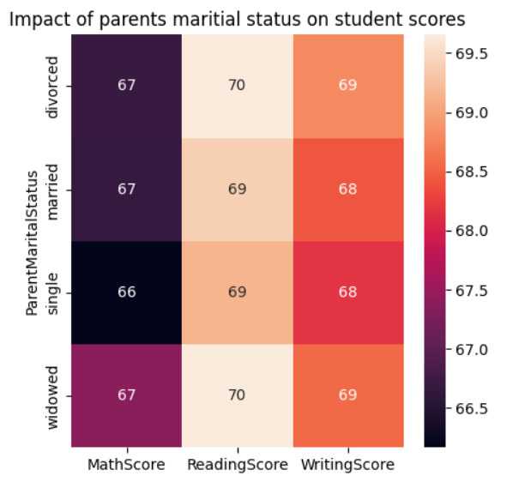

4.4 Outlier Detection
- Boxplots for Math, Reading, and Writing scores reveal no abnormal outliers, as all values fall within the expected 0–100 range.
- The absence of extreme or irregular data points reinforces the dataset’s reliability and supports the validity of the conclusions drawn from it.
- The overall performance across Reading, Writing, and Math is similar, but the higher number of low scores in Math indicates that students generally struggle more in Math than in the other two subjects.
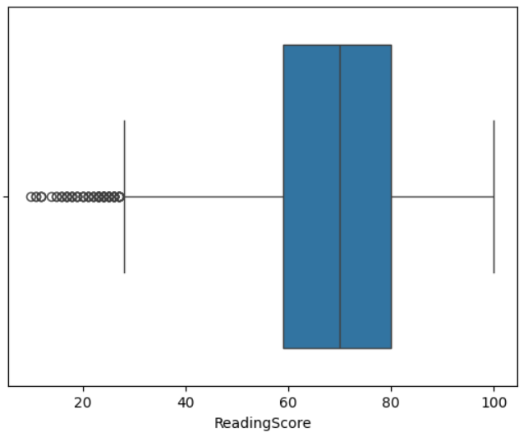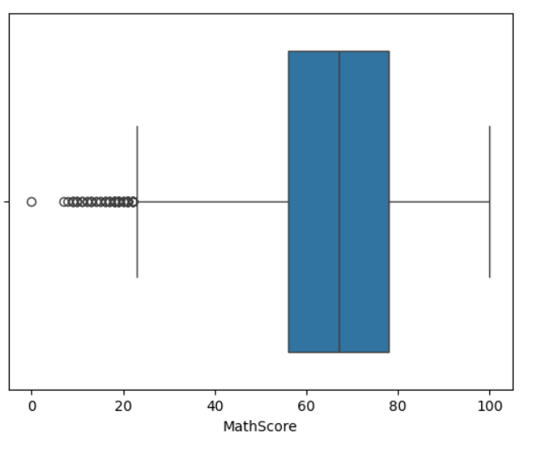
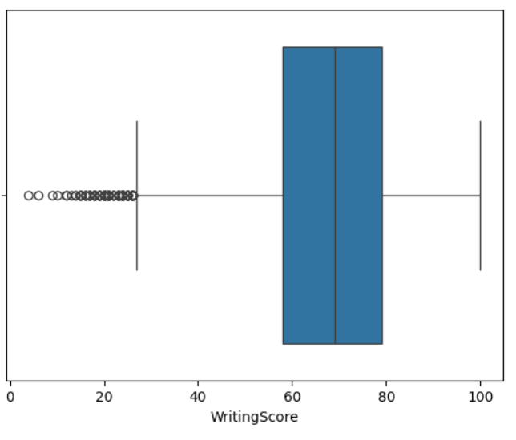
4.5 Ethnic Group Distribution
- Ethnic Group C is the largest represented demographic among all ethnic groups in the dataset, accounting for nearly one-third of all students.
- Other groups show varying but reasonable representation, making it possible to compare academic differences across ethnic categories if needed.
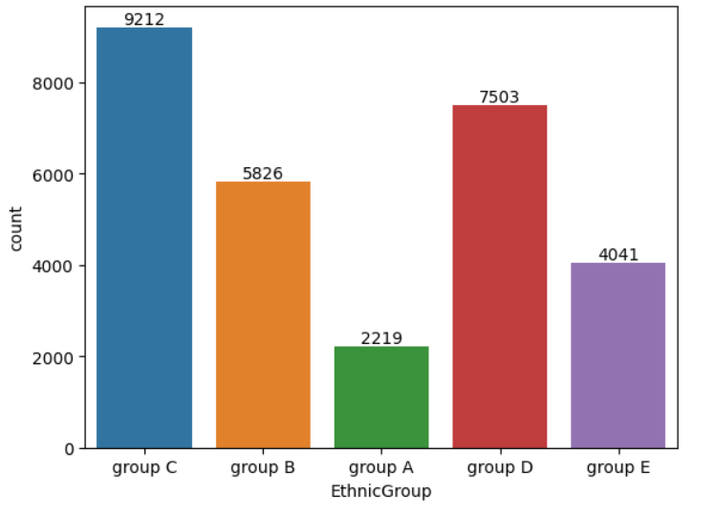
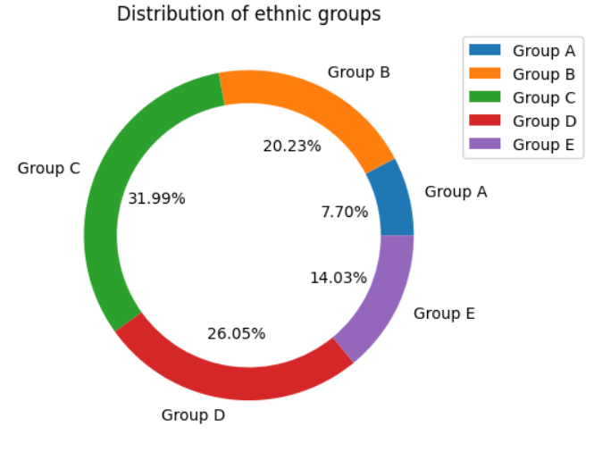
5. Conclusion
- The dataset is clean, large, and free from critical missing values in the academic score fields, making it reliable for analysis.
- Parental education emerges as the most influential factor affecting student performance, with higher education levels strongly associated with higher scores.
- Mathematics stands out as the comparatively weaker subject for most students when compared with Reading and Writing.
- Parent marital status has minimal impact, suggesting students’ academic performance depends more on educational environment and parental involvement than family structure.
- Ethnic group distribution is diverse, with Group C having the highest representation.
- Overall, the dataset provides rich insights into factors shaping student performance and helps guide targeted improvement strategies.
6. Recommendations (Schools & Educators)
- Strengthen math support with remedial classes, concept-based teaching, and engaging digital tools to improve problem-solving skills.
- Support parents with lower education through simple workshops, easy study guides, and regular communication to help them assist their children effectively.
- Implement consistent test preparation using mock exams, revision periods, and guided practice sessions to boost exam readiness.
- Create supportive study spaces such as quiet study hours, supervised homework zones, and resource rooms for extra help.
- Use continuous assessments to track progress, identify weak areas early, and personalize learning support.
- Promote literacy activities like reading clubs and writing workshops to strengthen Reading and Writing skills.
- Develop teacher mentorship programs and small-group learning sessions for students needing focused guidance.
- Teach effective study habits including time management, organized note-taking, and regular review routines.
- Improve parent–teacher communication to keep families informed and involved in student progress.
- Integrate digital learning tools to make subjects interactive, engaging, and personalized for students.

